Ultra-thin Multi-layer Composite Shielding Film for Tri-Zone Electromagnetic Isolation in Compact Sensor Pod
Date: 2026-07-20
Reference: Ultra-thin electromagnetic shielding film
TRIZ Principle: Composite materials (Principle #40)
Analysis Method: Substance-field analysis
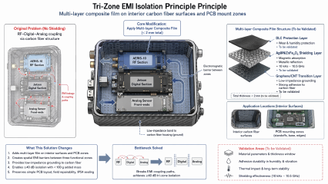

Core Concept
Cross-domain application: Apply a <2 mm thick multi-layer composite film to interior carbon fiber surfaces and PCB mounting zones to create spatial electromagnetic barriers between three functional zones:
- AERIS-10 RF Section
- Jetson Digital Section
- Analog Sensor Front-ends

Multi-Layer Composite Film Structure (< 2 mm total)
Layer | Material | Function | Status
Top | DLC Protection Layer | Wear & humidity protection | To be validated
Middle | Ag@NiZnFe₂O₄ Shielding Layer | Magnetic absorption + Metallic reflection (10 kHz – 10.5 GHz) | To be validated
Bottom | Graphene/CNT Transition Layer | Low-impedance grounding + Strong adhesion to carbon fiber | To be validated

What This Solution Changes
- Adds multi-layer film on interior surfaces and PCB zones
- Creates spatial EMI barriers between three functional zones
- Provides low-impedance grounding to carbon fiber housing
- Enables ≥40 dB isolation with <100 g total added film mass
- Preserves simple PCB layout, field repairability, and IP54 sealing

Bottleneck Solved
Original Problem: RF–Digital–Analog coupling via carbon fiber structure (no shielding) → EMI leakage & coupling paths between zones.
Solution: Breaks EMI coupling paths by inserting electromagnetic barriers between RF, Digital, and Analog zones. Achieves ≥40 dB tri-zone isolation while maintaining compact form factor.

Application Locations (Interior Surfaces)
- Interior carbon fiber surfaces
- PCB mounting zones (standoffs, base, edges)

Validation Areas (To Be Validated)
Area | Description
Material parameters | Thickness window optimization
Adhesion durability | Performance under humidity & vibration
Thermal impact | Long-term stability assessment
Shielding effectiveness | Verification across 10 kHz – 10.5 GHz

TRIZ Principle Applied
#40 Composite Materials — Transition from homogeneous to heterogeneous materials. Combine multiple material layers (graphene/CNT + Ag@NiZnFe₂O₄ + DLC) to achieve functions that no single material can provide alone: grounding, broadband shielding, and environmental protection in a single <2 mm film.

Key Advantages vs. Traditional Approaches
Traditional Approach | This Solution | Benefit
Separate metal enclosures | Ultra-thin composite film on existing surfaces | Mass savings, preserves compact form factor
Complex multilayer PCBs | Simple field-repairable PCB layout | Reduced cost, easier maintenance
Additional sealing gaskets | DLC layer + preserved IP54 sealing | Simplified assembly, humidity protection
Heavy shielding cans | <100 g total film mass | Meets weight-constrained pod requirements

Note: Material sourcing and adhesion durability under vibration require validation. All parameters to be confirmed through testing.

